**INNOVATION PHASE**

**WATER QUALITY ANALYSIS**

|  |  |
| --- | --- |
| **Date** | **10-10-2023** |
| **Team ID** | **1278** |
| **Project Name** | **Water Quality Analysis** |

**Table of Contents**

|  |  |
| --- | --- |
| 1 | Introduction |
| 2 | Problem Statement |
| 3 | Design and Innovation Strategies |
| 3.1 | Data Collection |
| 3.2 | Data Pre-processing |
| 3.3 | Model Selection and Training |
| 3.4 | Visualization |
| 4 | Conclusion |

**1. Introduction**

The objective of this document is to provide an in-depth analysis of the design and innovation strategies for the analysing water quality data to assess the suitability of water for specific purposes, such as drinking. Access to clean and safe drinking water is a fundamental necessity for human well-being. It is essential for maintaining public health and preventing waterborne diseases.

**2. Problem Statement**

Water quality analysis involves analyzing water quality data to assess the suitability of water for specific purposes, such as drinking. The objective is to identify potential issues or deviations from regulatory standards and determine water potability based on various parameters. This project includes defining analysis objectives, collecting water quality data, designing relevant visualizations, and building a predictive model.

**3. Design and Innovation Strategies**

**3.1. Data Collection**

**Innovation:** Comprehensive Data Gathering

In data collection, a meticulous and comprehensive approach to data collection is crucial to ensuring the accuracy and reliability of the analysis. Data on water quality parameters, including pH, hardness, total dissolved solids, chloramines, sulfates, conductivity, organic carbon, trihalomethanes, and turbidity, is gathered from various sources such as environmental agencies, water treatment facilities, and research institutions. The collected dataset undergoes thorough cleaning, preprocessing, and organization, forming the reliable foundation for subsequent analysis and predictive modeling efforts.

**3.2. Data Pre-processing**

**Innovation:** Natural Language Processing Technique

Handling Missing Values:

Missing values in the dataset are filled using appropriate techniques like mean or median imputation, ensuring data integrity without introducing bias. This step is crucial for maintaining the dataset's completeness and reliability.

Train-Test Split:

The dataset is divided into training and test sets, enabling the model to learn patterns from one subset and validate its performance on unseen data. This process assesses the model's ability to generalize, ensuring its accuracy and reliability in real-world scenarios.

Normalization:

Normalization techniques like Min-Max scaling or Z-score normalization are applied to standardize the range of features, ensuring equal contribution from all parameters. Normalization enhances the model's performance, making it capable of handling diverse units and scales within the dataset.

**3.3. Model Selection and Training**

**Innovation**: Ensemble Learning and Classification algorithms

Ensemble Learning and Classification algorithms techniques, including Random Forests, Gradient Boosting, Support Vector Machines , Neural Networks (like Multi-Layer Perceptrons), Decision Trees (especially in ensemble methods like Random Forest), and K-Nearest Neighbors.

Random Forest and Gradient Boosting are robust, capturing intricate patterns; SVM handles high-dimensional data effectively, neural networks model complex relationships, decision trees are interpretable, and KNN works well for similar instances.

**3.4. Visualization**

**Innovation**: IBM Cognos Platform

With Cognos Analytics create a new dashboard within tabs, and use an automatic method to create a visualization.

For water quality visualization, consider employing techniques like Heatmaps to show parameter correlations, Boxplots to display parameter distributions, Choropleth Maps for geographical insights, Parallel Coordinates for multi-dimensional comparisons, and 3D Surface Plots for intricate parameter relationships.

Time series visualizations such as Line Graphs can reveal trends over time. Interactive Dashboards, created using tools like Tableau or Plotly, enhance user engagement by allowing dynamic exploration of data.

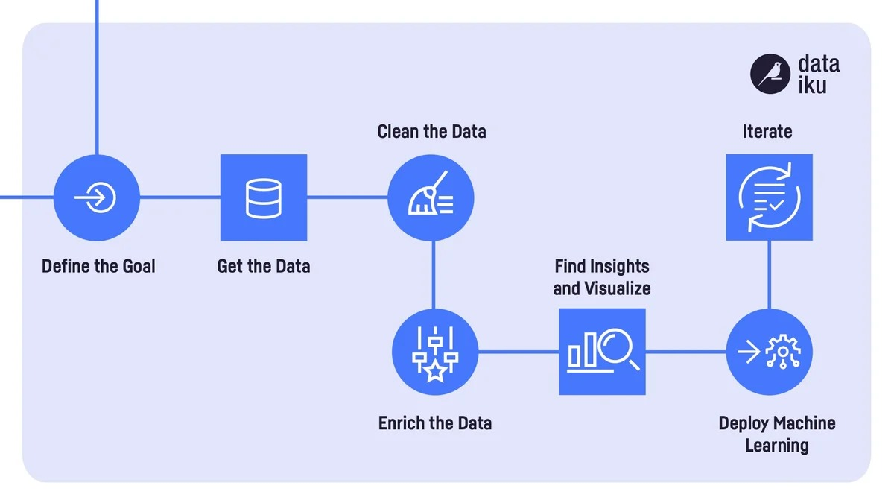

**4. Conclusion**

This document outlines the innovative journey we embark on to transform Water quality analysis and visualization. Through meticulous data collection, innovative preprocessing techniques, and the application of advanced machine learning models, we have deciphered crucial patterns and correlations within the data. By embracing innovation in data analysis and modeling, we've taken a significant step towards ensuring safe, reliable water sources, contributing to healthier communities and more informed decision-making processes.